**Mongo DB Installation Guide for Mac**

Guide for downloading and installation of MongoDB on Mac for the ["MongoDB Course @ SoftUn".](https://softuni.bg/modules/96/js-web)

# Download the MongoDB TGZ Installer Package

Download the current version of MongoDB from [here](https://www.mongodb.com/try/download/community). Make sure you **select TGZ** as the package you want to download:

# Installing MongoDB 7.0.4

Navigate to your download folder and double click on the **.tgz** package you just download. This will launch the installation wizard.

1. Open the terminal:

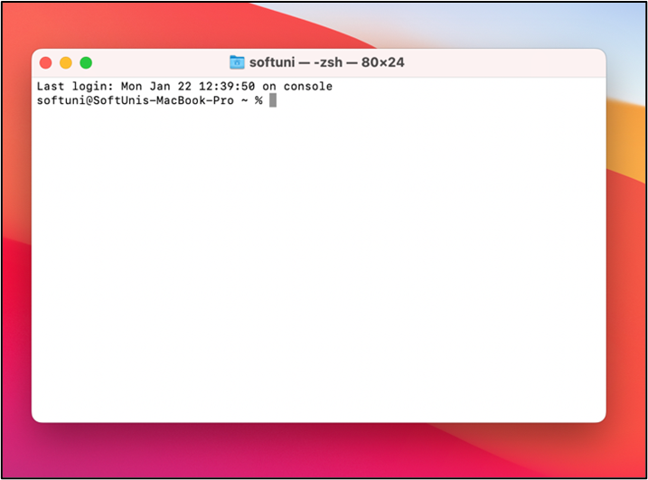

1. Check your main folder with command – **pwd**

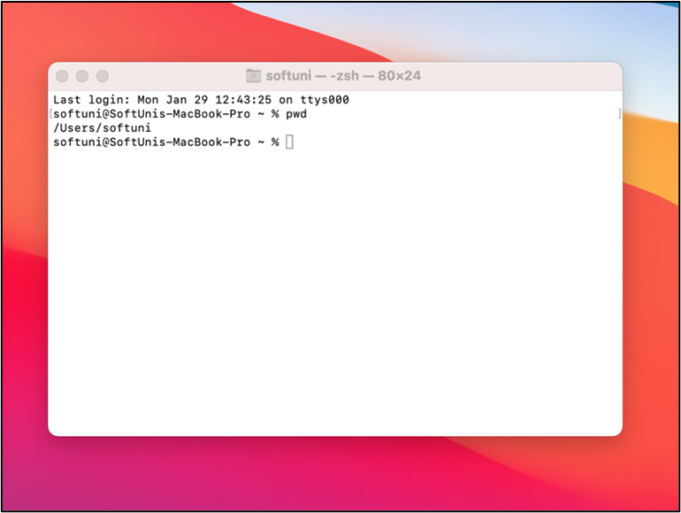

1. Find Downloads folder with command – **cd Downloads**

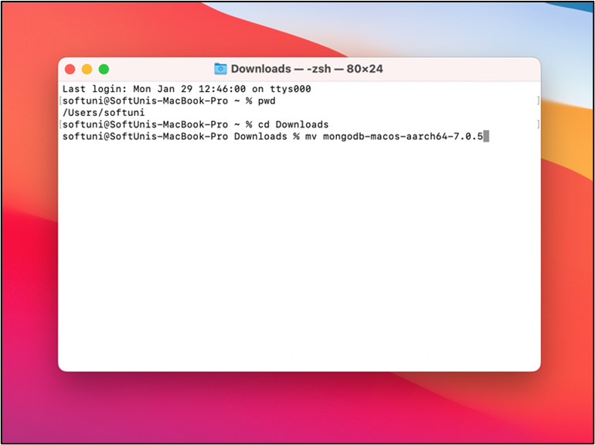

1. Move MongoDB folder into your main folder with command – **mv {MongoDB folder's name} {your main folder's path}**

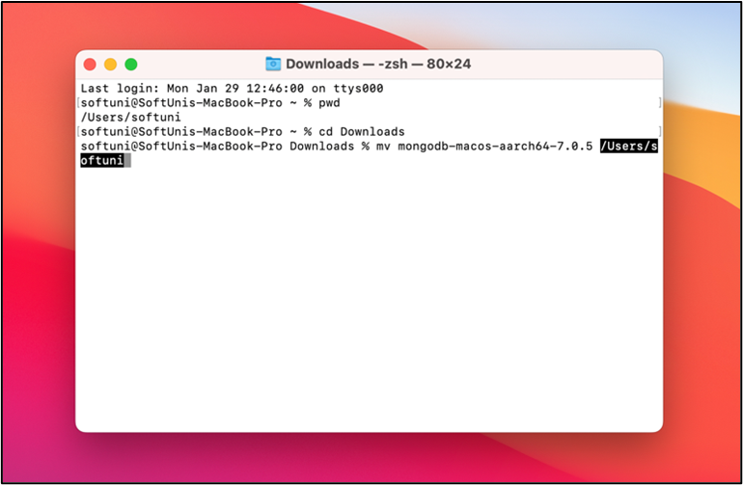

1. Check if you have MongoDB in your directory – **ls -al**

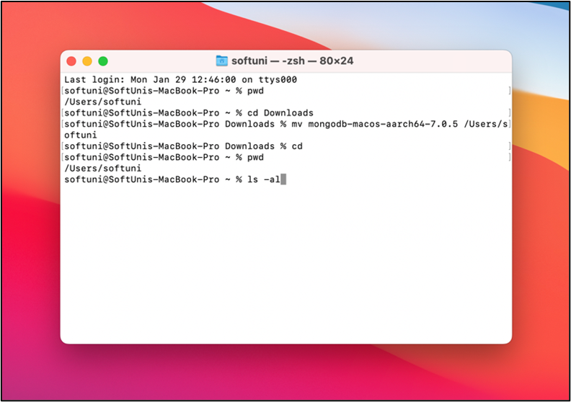

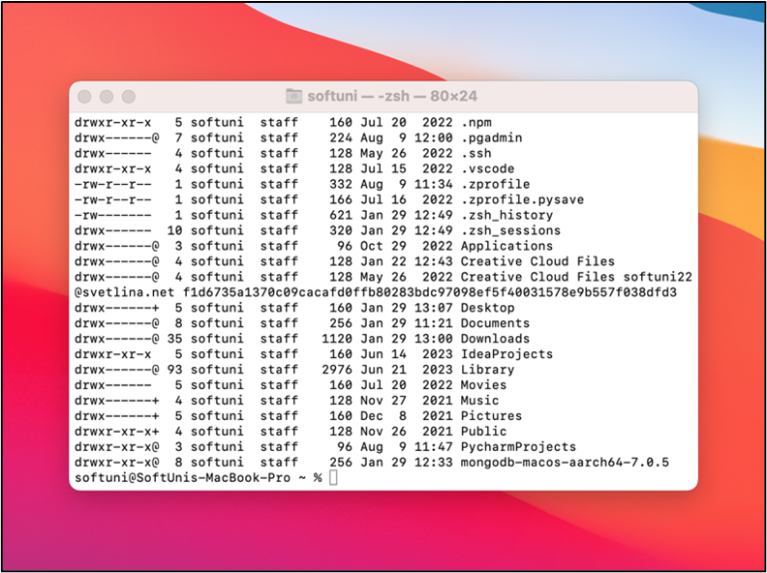

# Run MongoDB

Navigate to the installed MongoDB **bin** folder

1. Enter in the MongoDB folder and command – **ls**

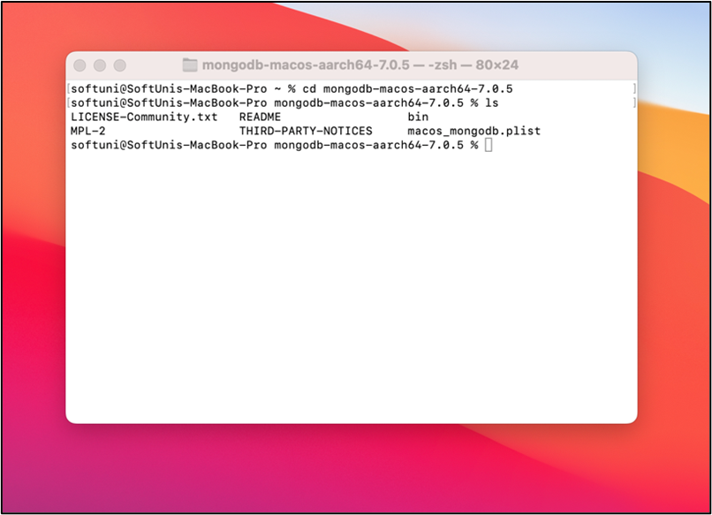

1. After that, enter to the **bin** folder – **cd bin**
2. Check if you have **.zshrc** file
   1. Return in your main folder with - **cd**
   2. Type ls -al and find .**zshrc**
3. If there is no such file you must create it with command – **touch .zshrc**
4. Open .zshrc file – **open .zshrc**

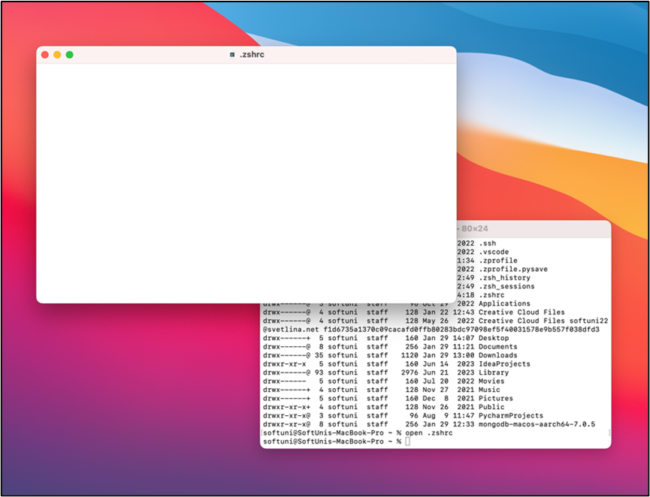

1. You must export MongoDB path
   * Copy the path to the **bin** folder
   * Export the path in the **.zshrc** file

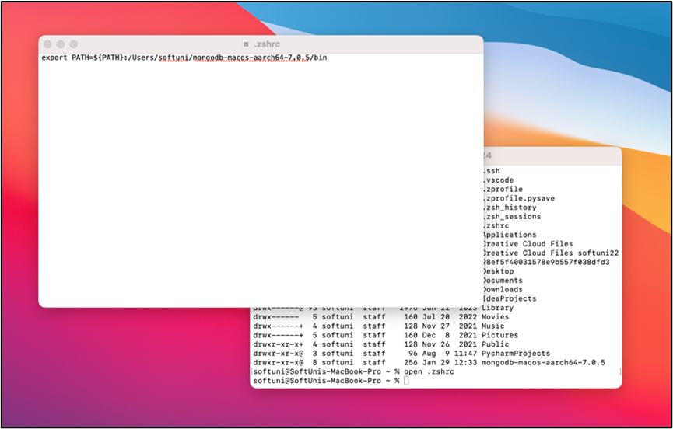

1. Write in to the terminal – **source .zshrc** and press **ENTER**
2. Create data/db

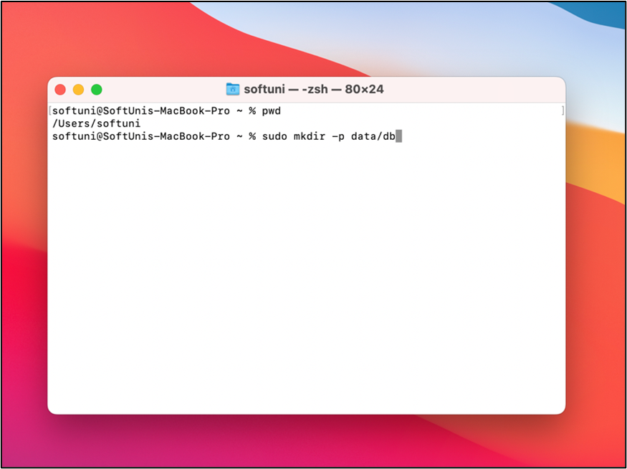

1. After that, when you enter the command – **ls,** must must see **data** folder.

# Run MongoDB

To run MongoDB, run the **mongod** process at the system prompt. If necessary, specify the path of the **mongod** or the data directory. See the following examples:

1. **Run without specifying paths.**

If the system PATH variable including the location if the **mongod** binary and if you use the default data directory (i.e., /data/db), simple enter **mongod** at the system prompt.

1. **Specify the path of the mongod.**

If your PATH does not include the location of the **mongod** binary, enter the full path of the **mongod** binary at the system prompt – **{path of binary}/mongod**

1. **Specify the path of the data directory.**

If you do not use the default data directory (i.e., /data/db), specify the path of the data directory using the **–dbpath** option – **mongod –dbpath {path to data directory}**

# MongoDB Compass

Download MongoDB Compass from [here](https://www.mongodb.com/try/download/compass).

Easily explore and manipulate your database with Compass. Intuitive and flexible, Compass provides detailed schema visualization, real-time performance metrics, sophisticated querying abilities, and much more.

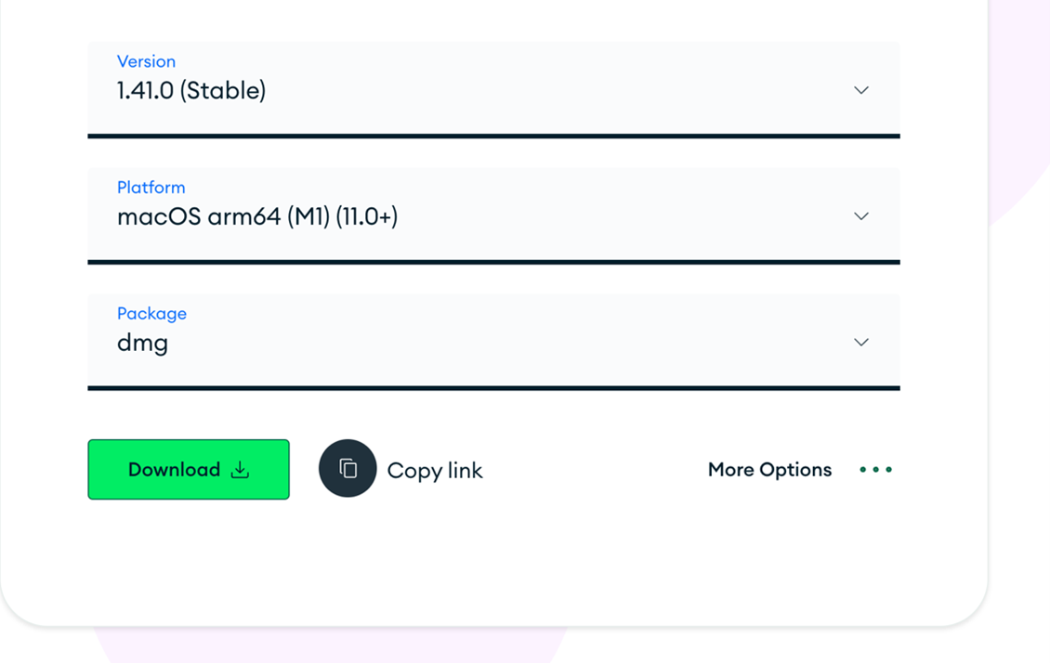

# Installing MongoDB Compass

1. Drag MongoDB Compass into Application folder.

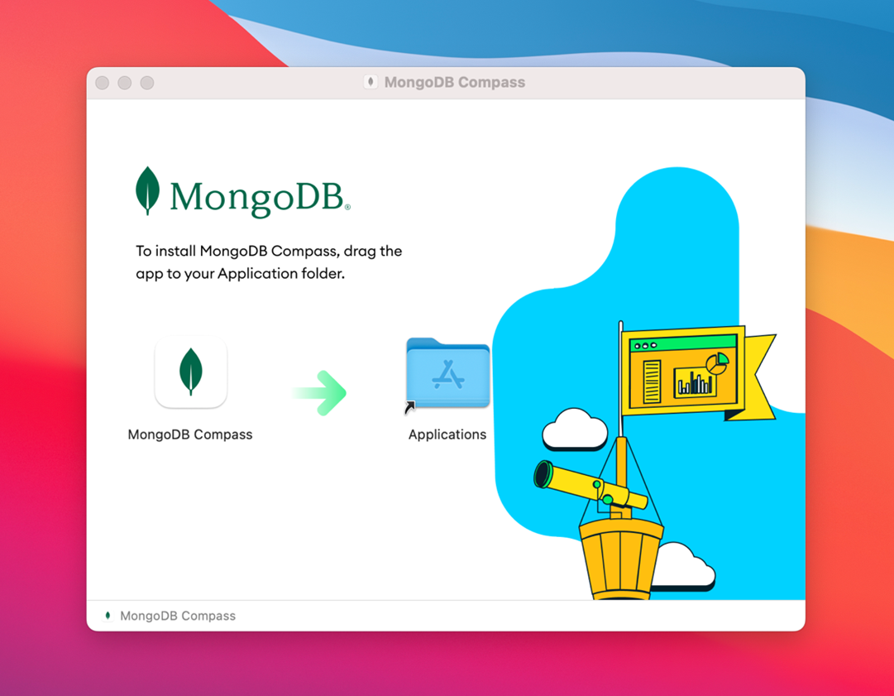

1. Enjoy

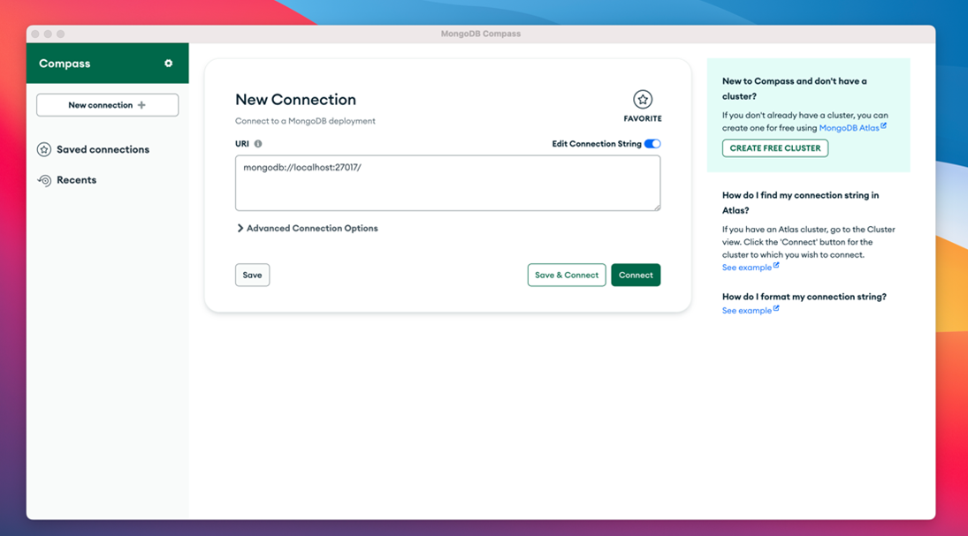

More information you can find [here](https://www.mongodb.com/docs/compass/master/).